**Computational Neuroscience**

Goal – how brains generate behaviours

Understand Brain using computational models

1. Descriptive models of the Brain(**what**) – encoding,decoding models like controlling prosthetic hand with this
2. Mechanistic models of brain cells(**how**) – human brain project in Europe – computer simulation of large networks of neurons
3. Interpretive(Normative) models (**why** )– why do the brain circuits operate the way they do, computational principles

Quantitatively describe what a biological neuron is with experimental data

Simulate on a computer the behavior of neurons

Formulate computational principles to explain the operations of brain

Receptive field – specific properties of a sensory stimulus that generate a strong response from the cell

Retina Ganglion cells

Center surround receptive fields in retina

1. On center off surround
2. Off center on surround

Nucleus – LGN

Primary visual cortex – if we record from here

Reverse correlation for quantifying the receptive fields

Mechanistic models

Center surround to oriented receptive fields. This is all about mechanistic models

How are these constructed. Feed forward connection

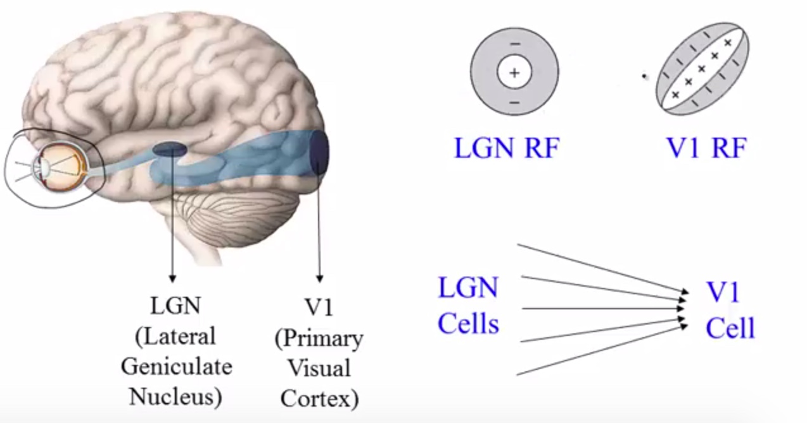

Interpretive models

Why are receptive fields are in this orientation

What are the computational advantages of receptive fields?

Efficient Coding hypothesis – represent images as faithfully and efficiently as possible

Reconstruct images after combing RF – linear combination

What are the RF that minimize the total squared pixel wise errors between image and image reconstruct and are as independent as possible

1. Sparse coding
2. ICA
3. Predictive coding

NeuroBiology – neurons, synapses and brain regions

Electrical personality of neurons

Neuron doctorine-

1. Fundamental unit of brain
2. Discrete cells and not continuous
3. Info flow from dendrites to the axons

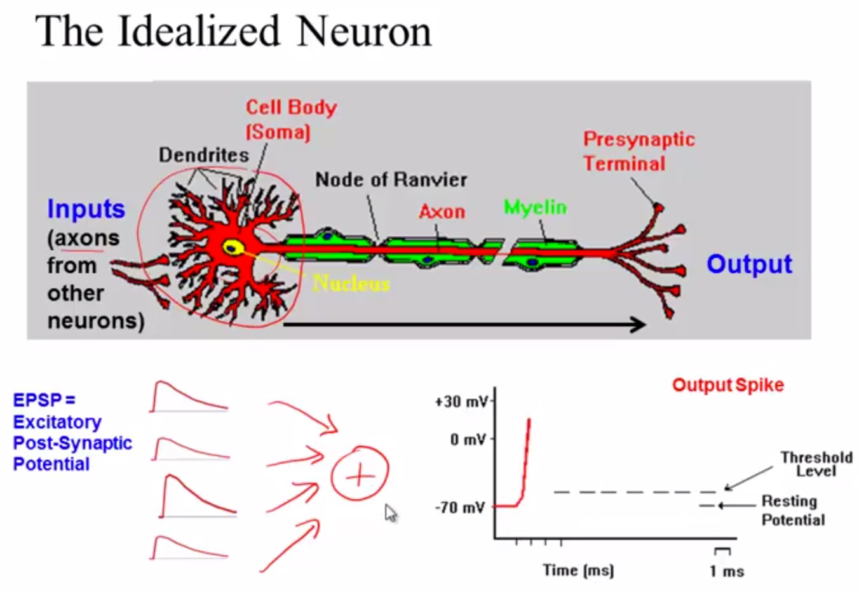

Strong enough depolarization will result in spike or action potential

Saltatory conduction

Node of Ranvier

What happens at synapse

Synapse is a connection between 2 neurons

1. Gap junctions
2. Neurotransmitters

Excitatory or inhibitory synapse

Synapses are the basis for memory and learning

What is Synaptic Plasticity?

Long term potentiation eg of a growl to identifying a tiger

Long term depression

Both LTP and LTD are imp for learning sequences

Why of the brain

Perception, action and cognition

Periphery Nervous System

1. Somatic

Afferent and efferent nervous system

1. Autonomous – heart ,blood levels below the level of consciousness, digestion,

Central Nervous system – spinal cord +brain

Spinal cord responsible for local feedback loops

What is neural code

Techniques/tools

Top down effects

Response models – P(response|stimulus)